Soal Prioritas 1
Buat Folder baru di github
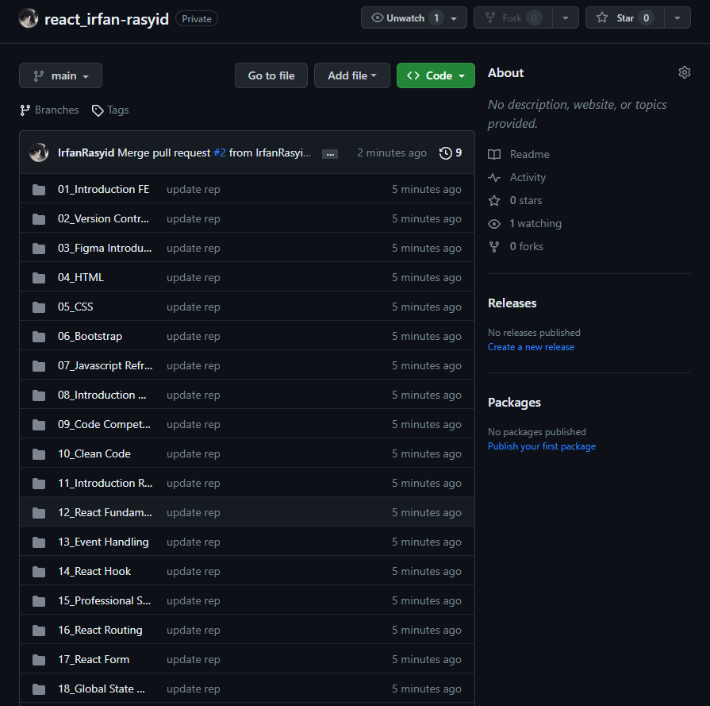

Soal Prioritas 2
Branch Baru
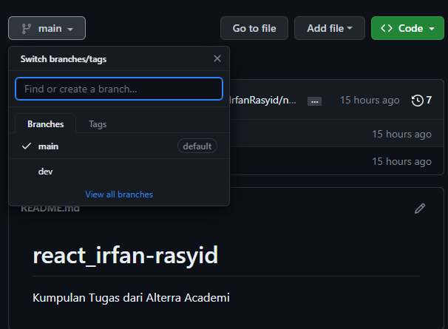
Pull Request
